Algebra 3-4 Name: __________________
Date: ___________________

Write the quadratic equation in standard form. Determine the vertex, whether the graph opens up or down, and the axis of symmetry.

1. y = 3 – x – x² 2. y = 4 – 3x²

Vertex: ________ Vertex: __________
Opens: UP or DOWN Opens: UP or DOWN
Axis of Symmetry: ___________ Axis of Symmetry: ___________

3. y = 3x + 3x² – 4 4. 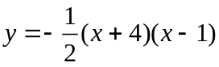

Vertex: ________ Vertex: __________
Opens: UP or DOWN Opens: UP or DOWN
Axis of Symmetry: ___________ Axis of Symmetry: ___________

Match the quadratic function with its graph.
5. y = x² + 2x – 15 6. y = (x + 3)(x – 5) 7. y = - (x + 1)² – 12

Graph the quadratic equation. Label the vertex and axis of symmetry.
8. y = x² + 1 9. y = 2x² – 12x
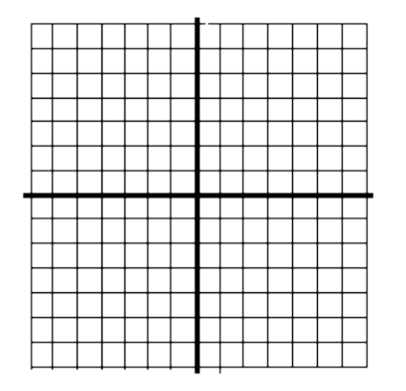

10. y = -x² + 8x + 2 11. y = (x – 2)² – 5

12. y = - (x + 2)² + 1 13. 